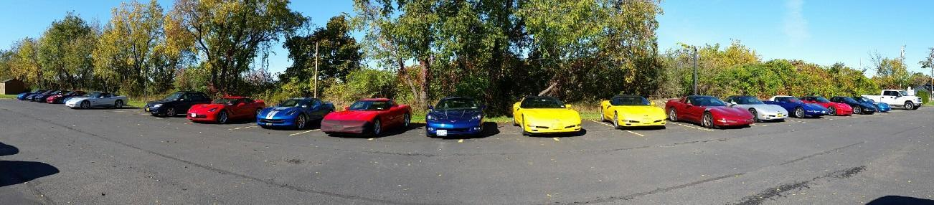
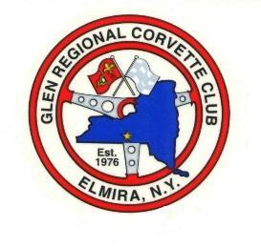
GRCC December 2018 Newsletter

President—Jim Storms 607-524-0005 Vice-President—Dale Bly 607-962-8277
Secretary—Keith McPherson 607-962-5717 Treasurer—John Holchuk 607-426-2257
Club Newsletter—Teresa Telehany 607-936-1269
Website: www.grcc76.wixsite.com/grcc Join our Facebook Club Page

The December club meeting was held at 7:00 at Elm Chevrolet on Tuesday, December 4th,, 2018.
Announcements and Discussions
This month’s meeting auction brought in $36.00. Bring in your items for the monthly charity raffle!
Welcome to our returning officers, who were elected by a resounding margin at this year’s Holiday Dinner.
Thanks to Keith McPherson for planning the Pre-Thanksgiving Brunch at the PennWells Inn. Wonderful, as usual!
Also, a big thanks goes out to Keith McPherson and Theresa Ellison for planning the annual Holiday Dinner. Delicious food, festive atmosphere, and great company made this year’s dinner a rousing success!
The club received a donation request from the Horseheads Regional Animal Shelter. As in the past, the club voted to extend a helping hand. A $300 donation will be made to the animal shelter.
Sam Wells is ill, and get well wishes would be welcomed! Send your well wishes to Sam Wells, 109 Fairway Dr., Haine City, FL 33811.
Club dues are due! Please send your 2019 club dues of $30.00 to Toni Bourdette, 1258 Alder Run Rd., Millertion, PA 16936
Gifts for Able II at this year’s party will be sweatsuits with the club logo, as well as personal items such as body wash, slippers, and individual gifts.
Upcoming Events:
December
Saturday, December 1st--GRCC Holiday Party and Election of Officers starting at 5:00 p.m. at the Hilton Garden Inn, Horseheads, NY. Cost is $30 per person, and includes tax and gratuity. Happy Hour is at 5 p.m., with Dinner at 6 p.m. Payment can be made in advance or on the night of the dinner. Deadline to sign up is Monday, Nov. 26th...please call Keith McPherson at 607-962-5717. Dues will also be collected that evening for anyone who wishes to pay at that time.
Tuesday, December 4th--7:00 p.m. Club Meeting at Elm Chevrolet
Friday, December 7th--Able 2 Christmas Party--arrive at 6:30, dinner to follow at Guiseppes--singing starts at 7:00 p.m.
Saturday, December 15th--Wreaths Across America--starts at 11:30 with a ceremony, followed by the laying of the wreaths. Meet at Woodlawn Cemetery at Davis Street, in Elmira. Lunch will follow at Pietro’s.
Tuesday, December 18th--6:00 p.m.-- Dinner at Tomasso’s in Waverly. Call Carole Ellison to add or subtract your name from the list...607-302-0778.
January
Saturday, Jan 19,2019 ---Wreaths Across America pick up---at 12 noon--This is the date to pick up the wreaths at Woodlawn National Cemetery in Elmira. Any members that will be attending, please bring a long handl,, (ex: rake handle), to carry the wreaths as this will make it easier to carry. If weather is predicted to be bad, the date may be changed to January 26.
Sunday, Jan. 13th, 2019--2:00 p.m. Event Planning meeting at Jim and Christal Storms’ house. (1486 Caton Rd., Corning) Bring snacks if you choose, and BYOB. Bring along ideas for 2019 events!

