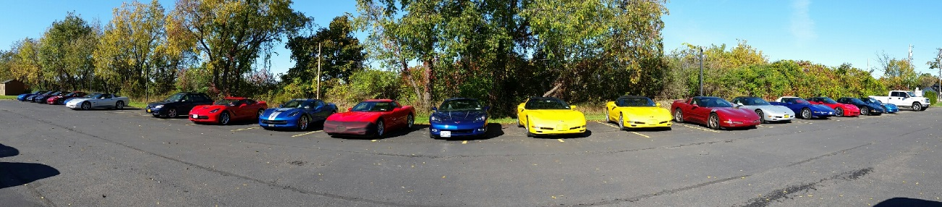
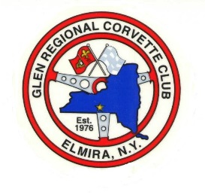
GRCC
December 2015 Newsletter

President—Jim Storms Vice-President—Chrystal Storms 607-524-0005
Secretary—Keith McPherson 607-962-5717 Treasurer—John Holchuk 607-426-2257
Club Newsletter—Teresa Telehany 607-936-1269

The December club meeting was held at 7:00 at the Arnot Mall on Tuesday, December 1, 2015. Until further notice, the club meetings will be held across from the ICE Gymnastics center.
Announcements and Discussions:
This month’s meeting auction brought in $38.00. Don’t forget to bring in your items for the charity auction for each monthly meeting.
Thank you messages were read to the club…
…from the SNAP organization, in thanks for our donation to the spaying and neutering program.
…from the Philadelphia Ronald McDonald House for our pop can top donation, organized by Dale and Marla Bly.
Thanks to the Quilters group who worked so hard on the 55 quilts given to the returning veterans on the Honor Flight to Washington, D.C. What an amazing gift! Everyone who attending the welcome home celebration at the airport had an amazing and inspiring time.
Elm Chevrolet would like our club to return our meetings to their location. They would like to offer a variety of incentives if we decide to do so. A representative from Elm Chevrolet will be at the club meeting in January to visit with the club, and to answer any questions you might have about this possible change.
The club voted to donate $100 to the Salvation Army After-School Program, rather than making a donation to the main holiday collection. They offer transportation from the elementary schools, as well as food and activities for every child. They are currently serving 91 children (out of a possible 113 available spots).
The Pre-Thanksgiving brunch at Lambs Creek Restaurant in Mansfield was well attended and delicious. Following the brunch, eight cars continued on to visit Reptile Land, organized by Brett Bourdette.

Upcoming Events:
December—
Friday-December 4th—Able 2 Christmas party, Old Ithaca Rd., in Horseheads, NY at 7:00 p.m. Dinner following the party will be at 8:00 p.m. at Giuseppe’s in Grand Central Plaza (by the Kmart).
Sunday-December 6th—Club Christmas Dinner and Election of Officers at Lib’s Supper Club in Elmira
Following the dinner on the 6th, the club re-elected all the officers to another term. We thank them for their hard work and dedication to our club!

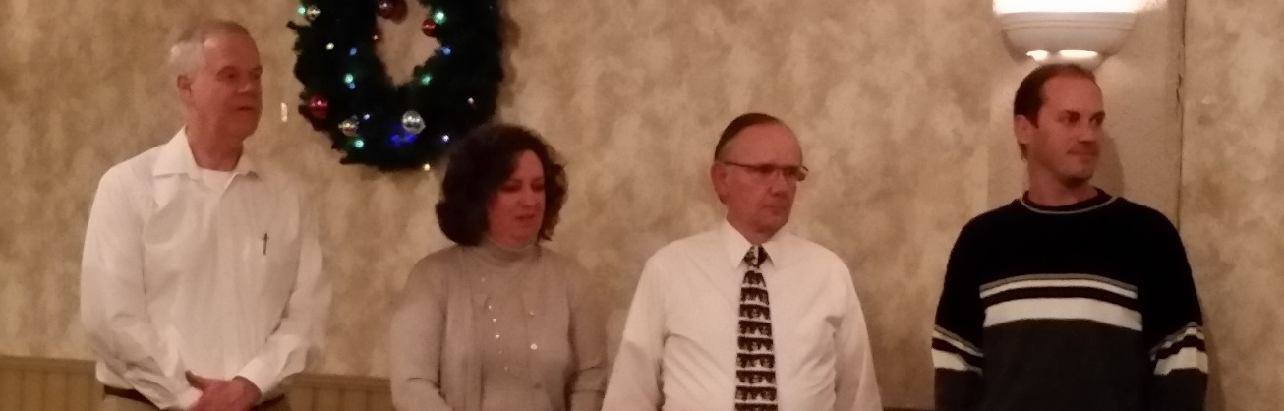
Keith McPherson Chrystal Storms Jim Storms John Holchuk
Secretary Vice-President President Tressurer

December 15th—Annual Salvation Army Bell Ringing at the Horsehead’s Walmart
Contact Toni Bourdette if you’d like to participate, or if you need to know about your assigned time. (570-537-2459)
December 31st—New Year’s Eve party at Brett and Michelle Bourdette’s house in Millerton, PA. Bring a dish to pass!
January—
Tuesday, January 5th—Regular Meeting @ 7:00 p.m.

Watch for upcoming plans about the Super Bowl party at John Holchuck’s house and the Daytona 500 party at the Bourdettes’.
Members are encouraged to begin thinking about possible trips, gatherings, and activities that can be planned in the upcoming year…..

